From Mazenet-Srihari to Everyone 03:50 PM

9150027186

From Gopal - Cloud Computing Trainer to Everyone 05:14 PM

gopal.rhce@gmail.com

Sand box link:

<https://docs.microsoft.com/en-us/learn/modules/create-windows-virtual-machine-in-azure/3-exercise-create-a-vm>

<https://docs.microsoft.com/en-us/learn/modules/create-azure-storage-account/5-exercise-create-a-storage-account>

<https://github.com/Thejeshmm/MVCfirstproject1>

<https://github.com/Thejeshmm/GITHubDemo>

<https://www.digitalcitizen.life/connecting-windows-remote-desktop-ubuntu/>

Chaitra 1

Sreekar 2

Kosuri Gopi 3

Chandini 4

Beere Saikumar 5

Mahesh Kumar CV 6

Abhinav 7

Jayakumar 8

Manjunath 9

From 216648-Bhanupriya G to Everyone 02:41 PM

<https://docs.microsoft.com/en-us/learn/modules/create-azure-storage-account/5-exercise-create-a-storage-account>

From 161145_Srikantamurthy HM to Everyone 02:41 PM

<https://docs.microsoft.com/en-us/learn/modules/create-azure-storage-account/5-exercise-create-a-storage-account>

From Gopal - Cloud Computing Trainer to Everyone 02:42 PM

<https://docs.microsoft.com/en-us/learn/modules/create-azure-storage-account/5-exercise-create-a-storage-account>

<https://people.sc.fsu.edu/>

From Gopal - Cloud Computing Trainer to Everyone 04:57 PM

Sqlizer

From 161145_Srikantamurthy HM to Everyone 04:58 PM

<https://sqlizer.io/>

From Mahesh Kumar 214671 to Everyone 04:58 PM

<https://sqlizer.io/>

From 216648-Bhanupriya G to Everyone 04:58 PM

<https://sqlizer.io/>

From 213495 - Venkata Nagaraju Tadi to Everyone 05:00 PM

<https://sqlizer.io/>

<https://beautifytools.com/>

**18-07-22**

<https://docs.microsoft.com/en-us/learn/modules/create-windows-virtual-machine-in-azure/3-exercise-create-a-vm>

<https://www.virtualbox.org/wiki/Downloads>

<https://ubuntu.com/download/desktop>

for connecting Hadoop server:

Host IP - 54.85.143.224

User Name - hirwuser150430

Git installation:

<https://git-scm.com/download/win>

489 ls

490 mkdir demoapp

491 ls

492 cd demoapp

493 git init

494 ls

495 ls -a

496 ls -la

497 ls -ls

498 whoami

499 id

500 date

501 time

502 uptime

503 ls -la

504 clear

505 git date

506 cal

507 date

508 git status

509 git init

510 ls -ald

511 git config -global user.name"vellaturigopi"

512 ls -la

513 git status

514 git config --global user.name "gopi"

515 git config --global user.mail "vellaturigopi@gmail.com"

516 git status

517 list

518 git config --list

519 history

<https://www.tutorialspoint.com/codingground.htm>

Image recognization:-

<https://teachablemachine.withgoogle.com/train>

19-07-22

<https://www.eclipse.org/downloads/packages/>

<https://confluence.atlassian.com/jira064/jira-user-s-guide-720416011.html>

21-07-22

<https://github.com/aspnet/samples>

<https://docs.microsoft.com/en-us/visualstudio/msbuild/msbuild-task-reference?view=vs-2022>

<https://docs.microsoft.com/en-us/learn/modules/create-azure-storage-account/5-exercise-create-a-storage-account>

22-07-22

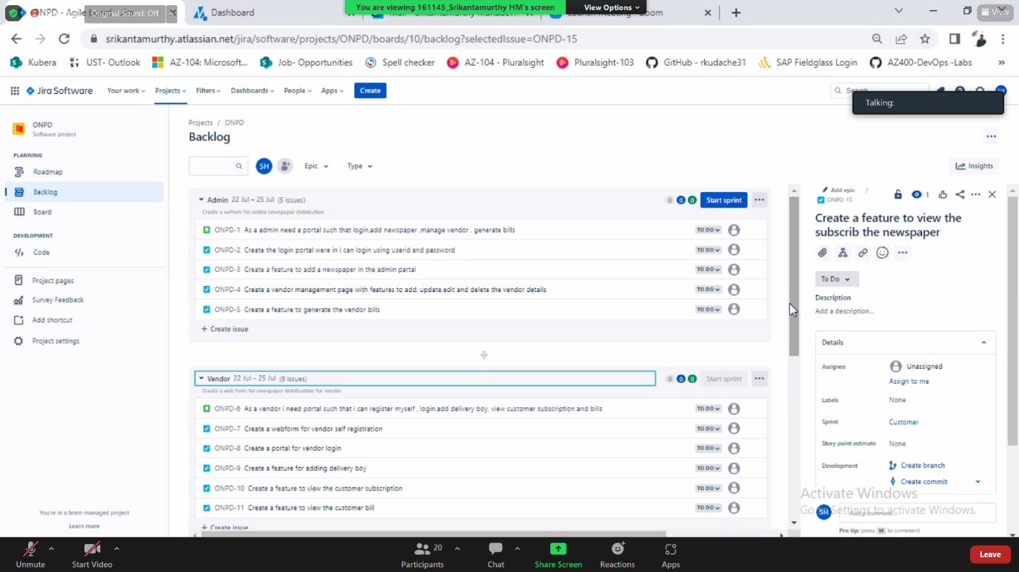

<https://app.diagrams.net/>

<https://downloads.digitaltrends.com/draw-io/windows>

25-07-22

From Gopal - Cloud Computing Trainer to Everyone 11:21 AM

<https://www.oracle.com/java/technologies/downloads/#license-lightbox>

<https://www.java.com/download/ie_manual.jsp>

From Gopal - Cloud Computing Trainer to Everyone 11:53 AM

<https://download.oracle.com/java/18/latest/jdk-18_windows-x64_bin.exe>

From 161145_Srikantamurthy HM to Everyone 12:11 PM

<https://download.oracle.com/java/18/latest/jdk-18_windows-x64_bin.exe>

<https://maven.apache.org/download.cgi>

29-07-22

From Gopal - Cloud Computing Trainer to Everyone 10:25 AM

<https://docs.microsoft.com/en->

From Gopal - Cloud Computing Trainer to Everyone 10:41 AM

<Target Name="CustomAfterBuild" AfterTargets="Build"><PropertyGroup> <_OutputCopyLocation>$(OutputPath)..\..\CustomOutput\</_OutputCopyLocation> </PropertyGroup> <ItemGroup> <_FilesToCopy Include="$(OutputPath)**\*"/> </ItemGroup> <Message Text="_FilesToCopy: @(_FilesToCopy)" Importance="high"/> <Message Text="DestFiles: @(_FilesToCopy->'$(_OutputCopyLocation)%(RecursiveDir)%(Filename)%(Extension)')"/>a. <!—Write a build statement which will copy all the output files to a new folder CustomOutput--> </Target> <Target Name="CustomClean" BeforeTargets="Clean"><PropertyGroup> <_OutputCopyLocation>$(OutputPath)..\..\CustomOutput\</_OutputCopyLocation> </PropertyGroup> <Message Text="Inside Custom Clean" Importance="high"/>

<ItemGroup>

<_CustomFilesToDelete Include="$(_OutputCopyLocation)**\*"/>

</ItemGroup>

From Gopal - Cloud Computing Trainer to Everyone 10:49 AM

<https://docs.microsoft.com/en-us/visualstudio/msbuild/msbuild-tasks?view=vs-2022>